**Null Object Design Pattern:** when we working with code we might face an issues with null pointer exception, because making operation on null value.

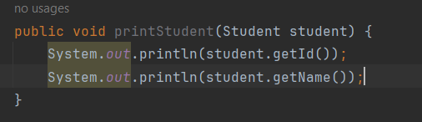

In above code if we send student value has null we will get nullPointerException to avoid this we have to do null check.

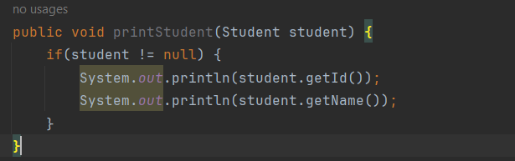

If we do if check like above it will increase code complexity, we have to avoid null check here.

In this scenario we have to use Null Object design pattern.

* A null Object replaces with NULL return type.
* No need to put if check for checking NULL.
* NULL object reflects do nothing or default baviour.

